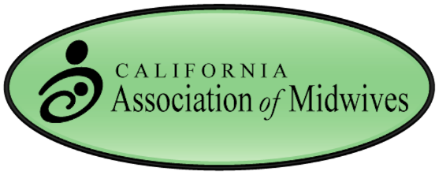

2015 Conference Discounted Financial Hardship Registration
The California Association of Midwives and the conference coordinators are deeply committed to ensuring accessibility of this conference to midwives, birth works and community members regardless of income/financial status.

We are accepting applications for discounted registration to the conference. We welcome applications from our membership, including practicing midwives, and student midwives. We appreciate receiving the applications as soon as possible. Discounted rates for the full conference will be arranged based on individual financial circumstances.

Please answer the following questions, and return to us with your registration information by mail, email or fax, titled ‘Financial Hardship Application.’ Please answer in no more than 400 words. Send emails to cfo@californiamidwives.org, or fax to (559) 642-6220, or mail to CAM c/o Jocelyn Dugan, 30648 Roaring River Dr., Coarsegold, CA 93614. All applications must be received by January 23, 2015.

- Full name, street address, phone number, email address.
- Describe your work or aspirations with childbearing families.
- Describe how your attendance at this conference will improve your ability to do your work/achieve your goals.
- Describe how your work/aspirations will help serve childbearing families in medically/midwifery underserved and otherwise marginalized communities.
- Please indicate an amount you are comfortable contributing to our conference.
- Please provide a relevant reference and contact info.

Thank you.

Best Regards,

The California Association of Midwives

